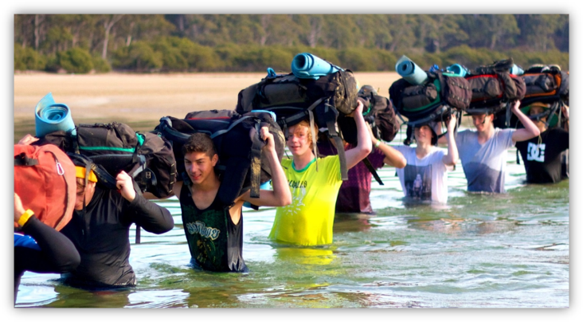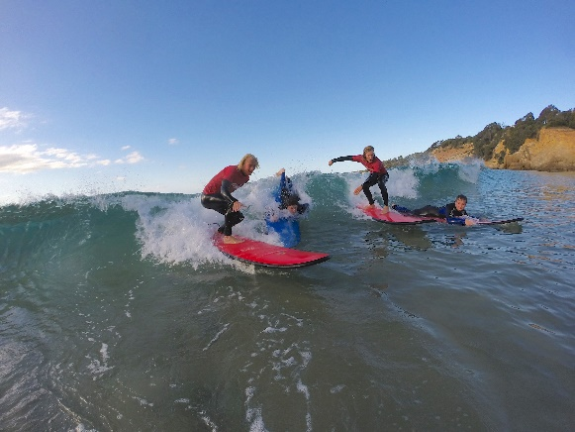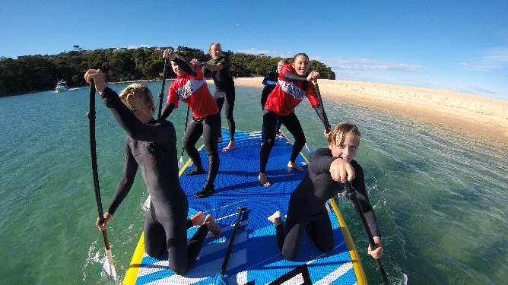

**Be inspired, challenge yourself and educate for the future.**

Coastlife is owned by Bindaree Outdoor Education Services which is a private company based in Melbourne’s eastern suburbs with a proud 30-year history specializing and delivering quality outdoor education programing to school and corporate groups throughout Victoria.

Coastlife has been providing exciting outdoor education experiences to students from across NSW, the ACT and Victoria for almost 26 years and was recently purchased by Bindaree.

We work collaboratively with schools to design, plan and deliver exceptional outdoor education programs on the Sapphire Coast of New South Wales. Every program is tailor made to the client group with an educational, professional and fun focus. Coastlife provides an all-inclusive service by combining transport, quality catering, comfortable accommodation and creative outdoor education activities into one complete camp package.

Coastlife works mainly with secondary schools to deliver sequential, progressive and educational outdoor camp programs. We strive to set the highest standards in areas of safety and professionalism as well as program and curriculum development and are seeking experienced Outdoor Educators and / or Coastal Activity leaders to join our team from 2020 and into the future.

***Key Responsibilities:***

**Within this role you will have the opportunity to:**

* Support and facilitate groups through adventure-based activities and camping programs
* Ensure activities are operated to the highest safety standards
* Challenge groups to work together to achieve successful outcomes
* Educate the students to apply skills learnt on program to their everyday life
* Encourage strong connections with our natural environment
* Help develop important life skills

***Applicants must hold a minimum of:***

* Valid Working with Children Check
* First Aid Qualification (Remote or Wilderness first aid is preferable)
* Current Drivers Licence
* Completed Cert IV in Outdoor Recreation or higher or specific activity qualifications
* Bronze Medallion (or equivalent / willing to get this)

***Experience:***

* Experience in working with youth is advantageous
* Experience in leading outdoor education programs is advantageous

***Desired qualifications:***

* Specialist qualifications: Surfing, Kayaking, Bushwalking SUPing

***How to apply:***

To apply please submit the following into the link below:

* Log Book
* Resume

**Base Location:** Kalaru, New South Wales, Australia

**Application Closing Date**: 1st February 2021

*Bindaree Outdoor Education Services is committed to safeguarding children and young people and all applicants must comply with to our child safe protection policies and recruitment process. We are an equal opportunity employer and applications from Aboriginal and Torres Strait Islander peoples and people from culturally and linguistically diverse backgrounds are encouraged.*

**For all questions relating to this role please contact the Program Staffing Manager:**  
**Shannon Grass at** [**Shannon.grass@coastlife.com.au**](mailto:Shannon.grass@coastlife.com.au)

**Thank you for your time and interest in this position.**

**We look forward to your application.**

**Workload:**   Casual

**Shannon Grass  
Coastlife Outdoor Education and Coastal Adventures**

**Email:**[**Shannon.grass@coastlife.com.au**](mailto:Shannon.grass@coastlife.com.au) **Website:**[**http://www.coastlife.com.au/**](http://www.coastlife.com.au/)

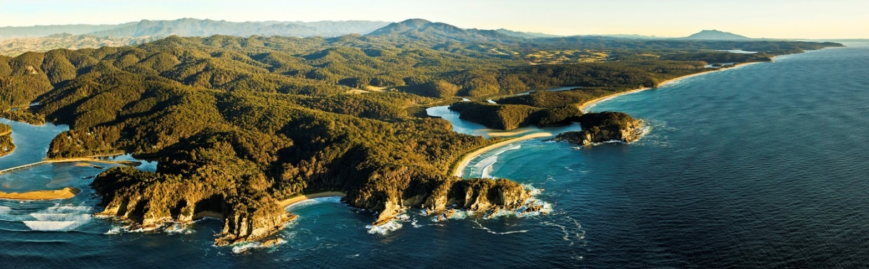

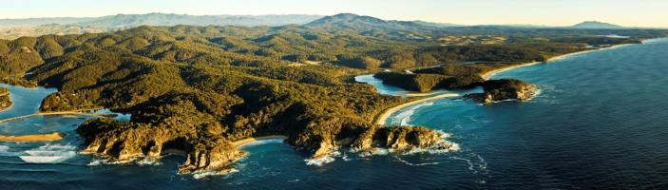

OUR CLASSROOM IS WILD!