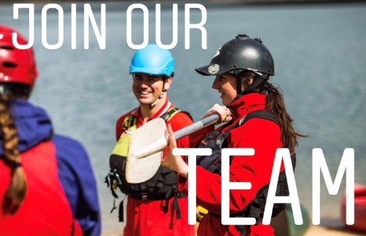

Casual Outdoor Educators

Be inspired, challenge yourself and educate for the future.

Bindaree Outdoor Education operates throughout Victoria within the State and National Parks utilising the beautiful country that we have on offer. Our journey, base and hardtop programs deliver hands on learning experiences to a variety of age and ability levels.

We are currently looking for passionate people to join our expanding program field team.

Whether you are new to the outdoor industry looking for a place to start or you are an experienced outdoor professional looking for a new challenge. Bindaree Outdoor Education has a variety of roles offering from single day and multi day work options.

We have a large range of programs that offer groups opportunities to partake in activities such as bushwalking, mountain biking, canoeing, white water rafting, rock climbing and more.

Key Responsibilities:
Within this role you will have the opportunity to:
- Support and facilitate groups through adventure-based activities and camping programs
- Ensure activities are operated to the highest safety standards
- Challenge groups to work together to achieve successful outcomes
- Educate the students to apply skills learnt on program to their everyday life
- Encourage strong connections with our natural environment
- Help develop important life skills

Applicants must hold a minimum of or be prepared to acquire:
- Valid Working with Children Check
- Remote Area first Aid or Wilderness First Aid Qualification
- Australian National Police Check
- Current Drivers Licence
- Completed Cert IV in Outdoor Recreation or higher

Experience:
- Experience in working with youth is advantageous
- Experience in leading outdoor education programs are an advantage
- Logged experience in specialised activities is advantageous

Desired qualifications:
- Specialist qualifications: climbing, biking, rafting or high ropes
- Bus Drivers Licence (LR or MR)

How to apply:
To apply please submit the following into the link below:
- Log Book
- Resume
https://form.jotform.co/81157804194863

Induction dates:
- New Staff Induction – 2nd – 4th February

Bindaree Outdoor Education Services is committed to safeguarding children and young people and all applicants must comply with to our child safe protection policies and recruitment process. We are an equal opportunity employer and applications from Aboriginal and Torres Strait Islander peoples and people from culturally and linguistically diverse backgrounds are encouraged.

For all questions relating to this role please contact the Program Staffing Manager:
Louis Callas - louis.callas@bindaree.com or 9720 9896

Thank you for your time and interest in this position.
We look forward to your application.

