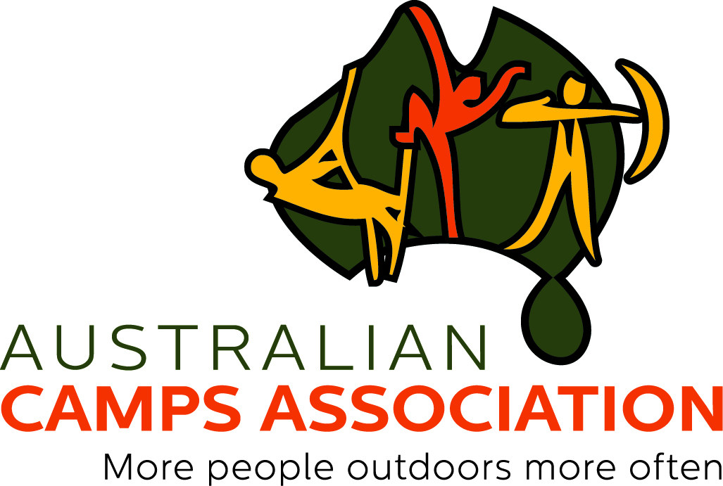

Preamble

Camps and outdoor activity providers need to know our sector's position on food needs vs food preferences - do we have a common position that helps us set up the best communications and expectations with guests, be they schools or community groups?

The ACA has worked closely with Allergy & Anaphylaxis Australia to prepare some material that members can use to describe how they deal with food needs/preferences and food/insect allergies – see Statement 1 and Statement 2.
This does not imply Allergy & Anaphylaxis Australia endorsement of all ACA member camps, but it does show that we are working together to help ensure the best possible experience for our guests.

The following communications from the Australian Camps Association on allergy management in camp facilities are supported by Allergy and Anaphylaxis Australia, https://www.allergyfacts.org.au/, Australia’s peak national patient support organisation.
Statement 1. Food requirements and food preferences

Please feel free to adapt this Statement as a template for your own facility.

(insert camp name)

(We) recognise that camp guests may have conditions (both diagnosed and undiagnosed) such as food allergy (including severe allergy and the risk of anaphylaxis), coeliac disease, gluten or lactose intolerances, etc which can place their health at risk if exposed to the relevant allergen / food trigger.

We also recognise that a guest’s diet may be influenced by other factors such as faith or ethical beliefs.

(We) acknowledge that not adhering strictly to such food requirements can, in certain circumstances, be life threatening.

(We) support participation in healthy camp experiences for people from all backgrounds through the provision of suitable menus and program design, provided that we receive comprehensive and timely (no less than ten working days) information prior to the guest’s arrival. Those with multiple or difficult to manage food allergies should have a direct conversation with catering staff prior to the camp. (We) reserve the right to refuse service to those guests with previously diagnosed conditions that do not provide us with adequate information to ensure that we can be suitably prepared to safely cater for their needs.

Participants that have a food (or insect) allergy should also draw this to the attention of camp staff in person immediately upon arrival - even if a registration form detailing their allergy has been submitted - and not assume that protocols to reduce risk of allergic reactions are in place. For children and teens up to age 18 years (including all school, sporting groups etc) the adults tasked with supervision should introduce children/students with food or insect allergy, including all at risk of anaphylaxis to camp staff.

(We) further recognise that some guests may also have food preferences, exposure to which may not necessarily result in damage to that person’s health or wellbeing if not met.

In these instances, our catering staff will do whatever is reasonably practical to meet each guest’s identified food preference; however, there will be times when some cannot be met.

-end of Statement-

Statement 2. Food and Insect Allergies

Please feel free to adapt this Statement as a template for your own facility.

(insert camp name)

(We) cannot guarantee that our venue is 100% free of any allergen including peanuts and tree nuts.

(We) try to avoid the use of peanuts and tree nuts in the foods we provide, however, (we) cannot guarantee that all of our food will always be free of peanuts and tree nuts.

We do not use peanuts or tree nuts as ingredients in food on our menu. We do use some foods labelled as ‘may contain traces of nuts’ for example. We do not use peanuts or tree nuts in any of our camp activities.

(We) strongly discourage groups, staff and students from bringing peanuts and tree nuts and foods containing peanuts and tree nuts to camp.

(We) work with guests or their parents / guardians to ensure that the menu meets requirements. This might include bringing suitably packaged and labelled food from home which will be stored and served appropriately.

If you or your child have a severe food allergy, please contact our catering staff no later than 10 working days prior to arrival at camp.

Participants that have a food (or insect) allergy should also draw this to the attention of camp staff in person immediately upon arrival - even if a registration form detailing their allergy has been submitted - and not assume that protocols to reduce risk of allergic reactions are in place. For children and teens up to age 18 years (including all school, sporting groups etc) the adults tasked with supervision should introduce children/students with food or insect allergy, including all at risk of anaphylaxis to camp staff.

-end of Statement-

